


CS4203T-D: DevOps

Laboratory Manual
Department of Computer Engineering

Author
Neha Jain,
Asst. Prof., Computer Engineering

Table of Contents

Sr . No. |  | Topic | Page No.
A. | Vision, Mission
B. | PEOs and POs
C. | PSOs
D. | Course Objectives and its mapping with POs and PSOs
F. List of Experiments
1. | Study of DevOps lifecycle and tools.
2. | Installation and configuration of Git and GitHub.
3. | Creating and managing repositories using Git (branching, merging, pull requests).
4. | Automating build and test using Jenkins.
5. | Creating CI/CD pipeline using GitHub Actions or GitLab CI.
6. | Docker installation and basic commands.
7. | Creating Dockerfile and building Docker images.
8. | Deploying a containerized application using Docker Compose.
9. | Introduction to Kubernetes: Pods, Deployments, Services.
10. | Deploying application on Kubernetes cluster.
11. | Infrastructure provisioning using Terraform.
12. | Configuration management using Ansible.
12. | Application monitoring using Prometheus and Grafana.
14. | Mini Project: End-to-end DevOps pipeline implementation

Vision and Mission of Institute

Vision of Institute
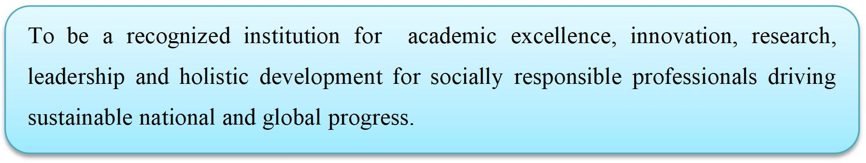
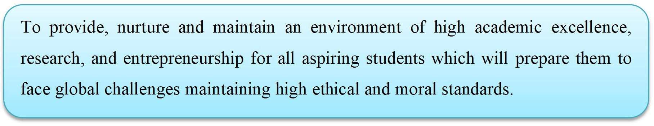
Mission of Institute

Vision and Mission of Department

Vision of Department


Mission of Department
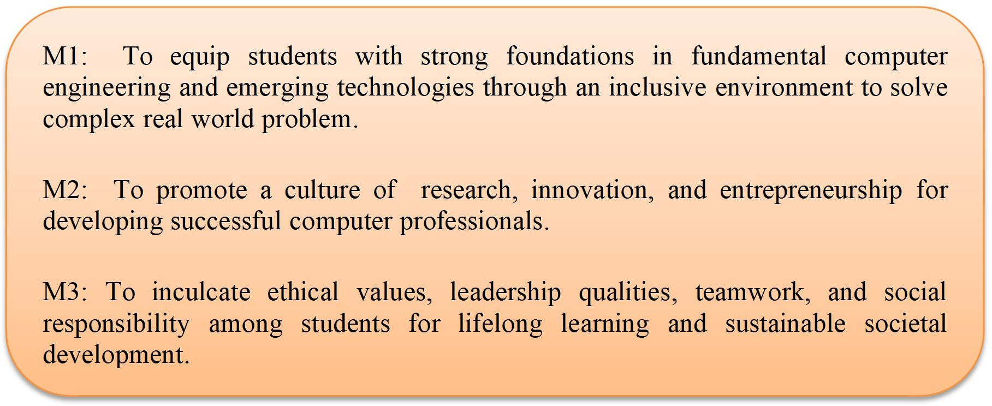



,

Program Educational Objectives (PEOs)
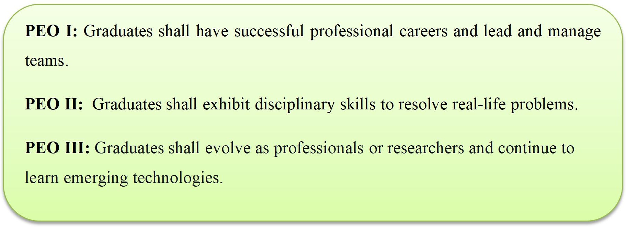

Program Specific Outcomes (PSOs)

A graduate of the Computer Engineering Program will demonstrate
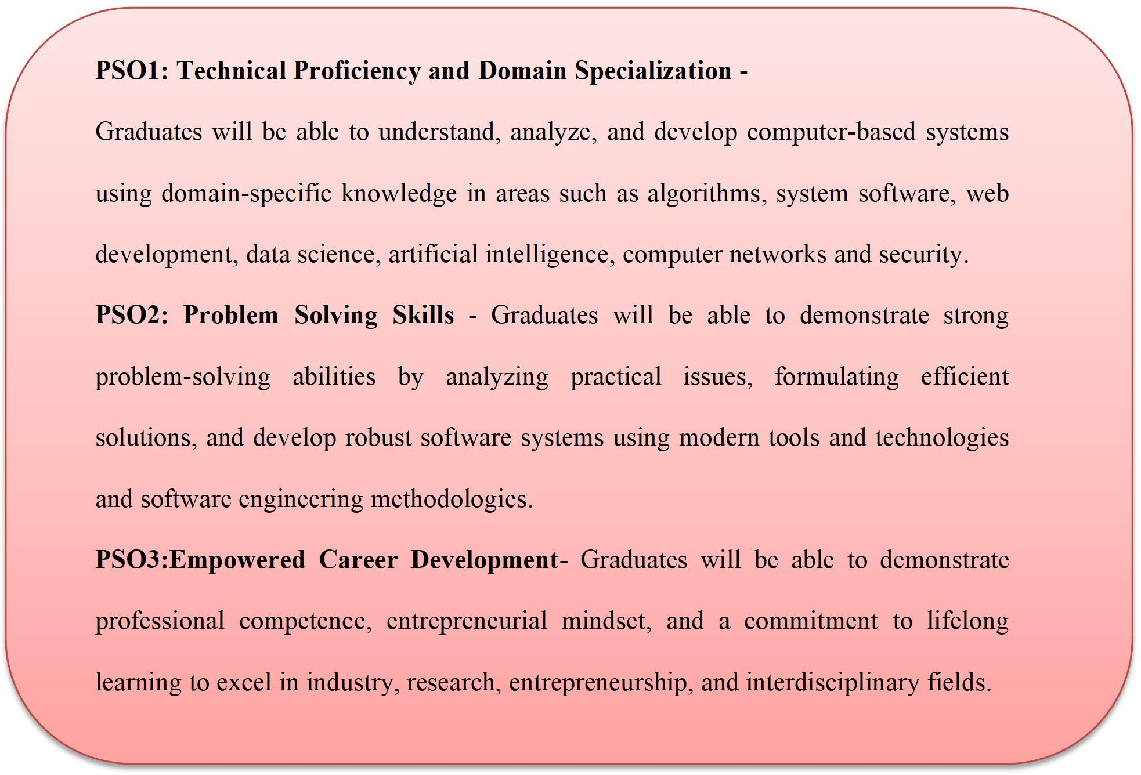

,

Knowledge and Attitude Profile (WK)

WK1: A systematic, theory-based understanding of the natural sciences applicable to the discipline and awareness of relevant social sciences.
WK2: Conceptually-based mathematics, numerical analysis, data analysis, statistics and formal aspects of computer and information science to support detailed analysis and modelling applicable to the discipline.
WK3: A systematic, theory-based formulation of engineering fundamentals required in the engineering discipline.
WK4: Engineering specialist knowledge that provides theoretical frameworks and bodies of knowledge for the accepted practice areas in the engineering discipline; much is at the forefront of the discipline.
WK5: Knowledge, including efficient resource use, environmental impacts, whole-life cost, reuse of resources, net zero carbon, and similar concepts, that supports engineering design and operations in a practice area.
WK6: Knowledge of engineering practice (technology) in the practice areas in the engineering discipline.
WK7: Knowledge of the role of engineering in society and identified issues in engineering practice in the discipline, such as the professional responsibility of an engineer to public safety and sustainable development.
WK8: Engagement with selected knowledge in the current research literature of the discipline, awareness of the power of critical thinking and creative approaches to evaluate emerging issues.
WK9: Ethics, inclusive behavior and conduct. Knowledge of professional ethics, responsibilities, and norms of engineering practice. Awareness of the need for diversity by reason of ethnicity, gender, age, physical ability etc. with mutual understanding and respect, and of inclusive attitudes.

,

Program Outcomes(POs)

- Engineering knowledge: Apply the knowledge of mathematics, science, engineering fundamentals, and an engineering specialization to the solution of complex engineering problems.

- Problem analysis: Identify, formulate, review research literature, and analyze complex engineering problems reaching substantiated conclusions using first principles of mathematics, natural sciences, and engineering sciences.

- Design/development of solutions: Design solutions for complex engineering problems and design system components or processes that meet the specified needs with appropriate consideration for the public health and safety, and the cultural, societal, and environmental considerations.

- Conduct investigations of complex problems: Use research-based knowledge and research methods including design of experiments, analysis and interpretation of data, and synthesis of the information to provide valid conclusions.

- Modern tool usage: Create, select, and apply appropriate techniques, resources, and modern engineering and IT tools including prediction and modelling to complex engineering activities with an understanding of the limitations.

- The engineer and society: Apply reasoning informed by the contextual knowledge to assess societal, health, safety, legal and cultural issues and the consequent responsibilities relevant to the professional engineering practice.

- Environment and sustainability: Understand the impact of the professional engineering solutions in societal and environmental contexts, and demonstrate the knowledge of, and need for sustainable development.

- Ethics: Apply ethical principles and commit to professional ethics and responsibilities and norms of the engineering practice.

- Individual and team work: Function effectively as an individual, and as a member or leader in diverse teams, and in multidisciplinary settings.

- Communication: Communicate effectively on complex engineering activities with the engineering community and with society at large, such as, being able to comprehend and write effective reports and design documentation, make effective presentations, and give and receive clear instructions.

- Project management and finance: Demonstrate knowledge and understanding of the engineering and management principles and apply these to one’s own work, as a member and leader in a team, to manage projects and in multidisciplinary environments.

- Life-long learning: Recognize the need for, and have the preparation and ability to engage in independent and lifelong learning in the broadest context of technological change.

Program Specific Outcomes (PSO) addressed by the Course:

A graduate of the Computer Engineering Program will demonstrate-

PSO1: Technical Proficiency and Domain Specialization - Graduates will be able to understand, analyze, and develop computer-based systems using domain- specific knowledge in areas such as algorithms, system software, web development, data science, artificial intelligence, computer networks and security.

PSO2: Problem Solving Skills - Graduates will be able to demonstrate strong problem-solving abilities by analyzing practical issues, formulating efficient solutions, and develop robust software systems using modern tools and technologies and software engineering methodologies.

PSO3: Empowered Career Development- Graduates will be able to demonstrate professional competence, entrepreneurial mindset, and a commitment to lifelong learning to excel in industry, research, entrepreneurship, and interdisciplinary fields.

CO | Description
CO1: | Use version control systems for collaborative development.
CO2: | Design and implement CI/CD pipelines.
CO3: | Build and deploy containerized applications.
CO4: | Use configuration management and infrastructure as code tools.
CO5 | Deploy applications on cloud platforms.
CO6 | Monitor applications and apply DevSecOps practices.

Practical Mapped with CO’s

S.No | Problem Statement | Co Mapped
1. | Study of DevOps lifecycle and tools. | CO1
2. | Installation and configuration of Git and GitHub. | CO1
3. | Creating and managing repositories using Git (branching, merging, pull requests). | CO1
4. | Automating build and test using Jenkins. | CO2
5. | Creating CI/CD pipeline using GitHub Actions or GitLab CI. | CO2
6. | Docker installation and basic commands. | CO3
7. | Creating Dockerfile and building Docker images. | CO3
8. | Deploying a containerized application using Docker Compose. | CO3
9. | Introduction to Kubernetes: Pods, Deployments, Services. | CO3, CO5
10. | Deploying application on Kubernetes cluster. | CO3, CO5
11. | Infrastructure provisioning using Terraform. | CO4
12. | Configuration management using Ansible. | CO4
13. | Application monitoring using Prometheus and Grafana. | CO6
14. | Mini Project: End-to-end DevOps pipeline implementation | CO1, CO2, CO3, CO4, CO5, CO6

Experiment 1: Study of DevOps Lifecycle and Tools

Aim
To study the DevOps lifecycle, its various phases, and the tools associated with each phase.

Theory / Concept
DevOps is a set of cultural philosophies, practices, and tools that combines software development (Dev) and IT operations (Ops) to shorten the development life cycle while delivering features, fixes, and updates frequently and reliably.
The DevOps lifecycle is typically represented as an infinite loop consisting of the following phases: Plan, Code, Build, Test, Release, Deploy, Operate, and Monitor. Each phase feeds continuous feedback into the next cycle, enabling Continuous Integration (CI) and Continuous Delivery/Deployment (CD).

Software / Tools Required
- Web browser / Internet access for research
- Notebook / Document editor for recording observations

Procedure
- Study each phase of the DevOps lifecycle and identify the primary objective of that phase.
- List the industry-standard tool(s) commonly used in each phase.
- Tabulate the phase, objective, and associated tools as shown below.

Expected Output

Viva Voce Questions
- What is DevOps and why is it needed?
- Differentiate between Continuous Integration, Continuous Delivery, and Continuous Deployment.
- Name the tool used in each phase of the DevOps lifecycle.
- What is the significance of the 'infinite loop' representation of DevOps?

Conclusion
The DevOps lifecycle phases (Plan, Code, Build, Test, Release, Deploy, Operate, Monitor) and their associated tools were studied. It was understood how DevOps bridges development and operations to enable faster, more reliable software delivery through automation and continuous feedback.

Experiment 2: Installation and Configuration of Git and GitHub

Aim
To install Git on the local machine, configure it, and set up a connection with a GitHub account.

Theory / Concept
Git is a distributed version control system (DVCS) that tracks changes in source code during software development, allowing multiple developers to work collaboratively. GitHub is a cloud-based hosting service for Git repositories that adds collaboration features such as issues, pull requests, and actions.

Software / Tools Required
- Git
- A GitHub account
- Terminal / Command Prompt
- SSH client (built into Git)

Procedure
Step 1: Install Git
- Windows: Download the installer from https://git-scm.com and run it with default options.
- Linux (Debian/Ubuntu): Install via apt package manager.
sudo apt update
sudo apt install git -y
- macOS: Install using Homebrew.
brew install git
Step 2: Verify Installation
git --version
Step 3: Configure Git (global identity)
git config --global user.name "Your Name"
git config --global user.email "youremail@example.com"
git config --global init.defaultBranch main
git config --list
Step 4: Create a GitHub Account
- Sign up at https://github.com and verify the email address.
Step 5: Generate and Add an SSH Key (secure authentication)
ssh-keygen -t ed25519 -C "youremail@example.com"
eval "$(ssh-agent -s)"
ssh-add ~/.ssh/id_ed25519
cat ~/.ssh/id_ed25519.pub # copy this key
- Paste the copied key into GitHub → Settings → SSH and GPG keys → New SSH key.
Step 6: Test the Connection
ssh -T git@github.com

Expected Output
git version 2.43.0
Hi <username>! You've successfully authenticated, but GitHub does not provide shell access.

Viva Voce Questions
- What is the difference between Git and GitHub?
- Why is SSH preferred over HTTPS for GitHub authentication?
- What does 'git config --global' do?
- What is a distributed version control system?

Conclusion
Git was successfully installed and configured with a user identity, and the local machine was linked to a GitHub account using SSH authentication, enabling secure push/pull operations.

Experiment 3: Creating and Managing Repositories using Git (Branching, Merging, Pull Requests)

Aim
To create a Git repository, work with branches, merge changes, and raise pull requests on GitHub.

Theory / Concept
A Git repository stores the complete history of a project. Branching allows developers to work on features in isolation without affecting the main codebase. Merging integrates changes from one branch into another. A Pull Request (PR) on GitHub is a request to merge changes from one branch/fork into another, typically after peer review.

Software / Tools Required
- Git
- GitHub account
- Terminal / Command Prompt

Procedure
Step 1: Create a Repository
- On GitHub, click 'New repository', name it (e.g., devops-lab), and initialize with a README.
Step 2: Clone the Repository Locally
git clone git@github.com:<username>/devops-lab.git
cd devops-lab
Step 3: Create and Switch to a New Branch
git checkout -b feature-login
# or, in newer Git:
git switch -c feature-login
Step 4: Make Changes and Commit
echo "console.log('login module');" > login.js
git add login.js
git commit -m "Add login module"
Step 5: Push the Branch to GitHub
git push -u origin feature-login
Step 6: Raise a Pull Request
- On GitHub, navigate to the repository → 'Compare & pull request' → add title/description → 'Create pull request'.
Step 7: Review and Merge the Pull Request
- Review the diff, resolve any conflicts if flagged, then click 'Merge pull request' → 'Confirm merge'.
Step 8: Sync Local main Branch
git checkout main
git pull origin main
git branch -d feature-login
Step 9: Handling Merge Conflicts (if any)
git merge feature-login
# If conflict markers <<<<<<<, =======, >>>>>>> appear:
# manually edit the conflicting file, then:
git add <resolved-file>
git commit -m "Resolve merge conflict"

Expected Output
The feature branch is successfully merged into main, and the commit history shows a merge commit linking both branches.

Viva Voce Questions
- What is the difference between 'git merge' and 'git rebase'?
- What is a merge conflict and how is it resolved?
- What is the purpose of a pull request?
- Differentiate between 'git fetch' and 'git pull'.

Conclusion
A Git repository was created and cloned locally; a feature branch was created, committed to, and pushed; and the changes were integrated into the main branch through a GitHub pull request, demonstrating a typical collaborative Git workflow.

Experiment 4: Automating Build and Test using Jenkins

Aim
To install Jenkins and configure a freestyle/pipeline job that automatically builds and tests source code pulled from a Git repository.

Theory / Concept
Jenkins is an open-source automation server used to automate the parts of software development related to building, testing, and deploying, facilitating Continuous Integration and Continuous Delivery (CI/CD). Jenkins jobs can be triggered manually, on a schedule, or automatically via webhooks when code changes are pushed to a repository.

Software / Tools Required
- Jenkins (WAR file or Docker image)
- Java (JDK 11 or 17)
- Git
- Sample project (e.g., Maven/Node.js app)

Procedure
Step 1: Install Java (Jenkins prerequisite)
sudo apt update
sudo apt install openjdk-17-jdk -y
java -version
Step 2: Install Jenkins (Ubuntu/Debian)
curl -fsSL https://pkg.jenkins.io/debian-stable/jenkins.io-2023.key | sudo tee /usr/share/keyrings/jenkins-keyring.asc
echo "deb [signed-by=/usr/share/keyrings/jenkins-keyring.asc] https://pkg.jenkins.io/debian-stable binary/" | sudo tee /etc/apt/sources.list.d/jenkins.list
sudo apt update
sudo apt install jenkins -y
sudo systemctl start jenkins
sudo systemctl enable jenkins
- Alternative: Run Jenkins in Docker for quick setup.
docker run -d -p 8080:8080 -p 50000:50000 --name jenkins jenkins/jenkins:lts
Step 3: Unlock Jenkins
- Open http://localhost:8080 in a browser, retrieve the initial admin password, and install suggested plugins.
sudo cat /var/lib/jenkins/secrets/initialAdminPassword
Step 4: Create an Admin User
- Follow the setup wizard to create the first administrator user.
Step 5: Create a New Freestyle/Pipeline Job
- Dashboard → New Item → enter name (e.g., 'MyApp-Build') → select 'Freestyle project' → OK.
Step 6: Configure Source Code Management
- Under 'Source Code Management', select Git and enter the repository URL and credentials.
Step 7: Add a Build Step
# Example build step (Execute shell):
npm install
npm test
npm run build
Step 8: Configure a Build Trigger
- Enable 'GitHub hook trigger for GITScm polling' or 'Poll SCM' with a schedule such as '* * * * *' for automatic builds.
Step 9: Run and Verify the Build
- Click 'Build Now' and inspect the 'Console Output' for build/test results.

Expected Output
Started by user admin
Checking out Git repository
Running npm install...
Running npm test... 12 passing
Finished: SUCCESS

Viva Voce Questions
- What is Jenkins and why is it used?
- Differentiate between a Freestyle project and a Pipeline job.
- What is a build trigger? Name a few types.
- What is a Jenkins agent/node?

Conclusion
Jenkins was installed and configured to automatically pull source code from a Git repository, run build and test steps, and report the results, demonstrating a basic Continuous Integration workflow.

Experiment 5: Creating a CI/CD Pipeline using GitHub Actions

Aim
To create a CI/CD pipeline using GitHub Actions that automatically builds, tests, and deploys code on every push.

Theory / Concept
GitHub Actions is a CI/CD platform integrated directly into GitHub that allows automation of build, test, and deployment workflows. Workflows are defined in YAML files stored in the '.github/workflows' directory and are triggered by repository events such as push, pull_request, or a schedule.

Software / Tools Required
- GitHub repository
- GitHub Actions (built-in, no separate installation)
- Sample Node.js/Java application

Procedure
Step 1: Create the Workflow Directory
mkdir -p .github/workflows
cd .github/workflows
Step 2: Create the Workflow File (ci-cd.yml)
name: CI/CD Pipeline

on:
push:
branches: [ main ]
pull_request:
branches: [ main ]

jobs:
build-and-test:
runs-on: ubuntu-latest
steps:
- name: Checkout code
uses: actions/checkout@v4

- name: Set up Node.js
uses: actions/setup-node@v4
with:
node-version: '20'

- name: Install dependencies
run: npm install

- name: Run tests
run: npm test

- name: Build application
run: npm run build

deploy:
needs: build-and-test
runs-on: ubuntu-latest
if: github.ref == 'refs/heads/main'
steps:
- name: Checkout code
uses: actions/checkout@v4
- name: Deploy (placeholder)
run: echo "Deploying application to server/registry..."
Step 3: Commit and Push the Workflow
git add .github/workflows/ci-cd.yml
git commit -m "Add CI/CD pipeline workflow"
git push origin main
Step 4: Observe the Pipeline Execution
- Go to the repository's 'Actions' tab on GitHub to view the workflow run, job logs, and pass/fail status for each step.
Step 5: (Alternative) GitLab CI Equivalent
- For GitLab, the same pipeline is defined in a '.gitlab-ci.yml' file at the repository root:
stages:
- build
- test
- deploy

build_job:
stage: build
script:
- npm install
- npm run build

test_job:
stage: test
script:
- npm test

deploy_job:
stage: deploy
script:
- echo "Deploying application..."
only:
- main

Expected Output
The Actions tab shows a green checkmark for each successful job (build-and-test, deploy) with expandable logs for every step.

Viva Voce Questions
- What is a YAML workflow file and where must it be located for GitHub Actions?
- What is the difference between a 'job' and a 'step' in GitHub Actions?
- What are GitHub Actions 'runners'?
- How can a job be made to depend on another job completing first?

Conclusion
A CI/CD pipeline was created using GitHub Actions (and an equivalent GitLab CI configuration), which automatically builds, tests, and deploys the application on every push to the main branch, demonstrating end-to-end pipeline automation.

Experiment 6: Docker Installation and Basic Commands

Aim
To install Docker Engine and practice fundamental Docker commands for managing images and containers.

Theory / Concept
Docker is a platform that uses OS-level virtualization to package applications and their dependencies into lightweight, portable units called containers. Unlike virtual machines, containers share the host OS kernel, making them faster to start and more resource-efficient.

Software / Tools Required
- Docker Engine / Docker Desktop
- Terminal / Command Prompt

Procedure
Step 1: Install Docker (Ubuntu/Debian)
sudo apt update
sudo apt install ca-certificates curl gnupg -y
sudo install -m 0755 -d /etc/apt/keyrings
curl -fsSL https://download.docker.com/linux/ubuntu/gpg | sudo gpg --dearmor -o /etc/apt/keyrings/docker.gpg
echo "deb [arch=$(dpkg --print-architecture) signed-by=/etc/apt/keyrings/docker.gpg] https://download.docker.com/linux/ubuntu $(lsb_release -cs) stable" | sudo tee /etc/apt/sources.list.d/docker.list
sudo apt update
sudo apt install docker-ce docker-ce-cli containerd.io docker-compose-plugin -y
- Windows/macOS: Download and install Docker Desktop from https://www.docker.com/products/docker-desktop.
Step 2: Verify Installation
docker --version
sudo docker run hello-world
Step 3: Manage Docker without sudo (Linux)
sudo usermod -aG docker $USER
newgrp docker
Step 4: Basic Image Commands
docker pull nginx:latest # download an image
docker images # list local images
docker rmi nginx:latest # remove an image
Step 5: Basic Container Commands
docker run -d -p 8080:80 --name web nginx # run container in detached mode
docker ps # list running containers
docker ps -a # list all containers
docker logs web # view container logs
docker exec -it web /bin/bash # open a shell inside the container
docker stop web # stop the container
docker start web # start it again
docker rm web # remove the container
Step 6: Inspect and Clean Up
docker inspect web
docker system df # view disk usage
docker system prune -a # remove unused images/containers/networks

Expected Output
Hello from Docker!
This message shows that your installation appears to be working correctly.

CONTAINER ID IMAGE COMMAND STATUS PORTS
a1b2c3d4e5f6 nginx "/docker-entrypoint.…" Up 2 minutes 0.0.0.0:8080->80/tcp

Viva Voce Questions
- How does a container differ from a virtual machine?
- What is the difference between 'docker stop' and 'docker kill'?
- What is a Docker image layer?
- What does the '-d' flag do in 'docker run'?

Conclusion
Docker Engine was successfully installed, and fundamental commands for pulling images, running, inspecting, and managing containers were practiced, establishing the foundation for containerized application development.

Experiment 7: Creating a Dockerfile and Building Docker Images

Aim
To write a Dockerfile for a sample application and build a custom Docker image from it.

Theory / Concept
A Dockerfile is a text document containing a sequence of instructions used by Docker to automatically build an image. Each instruction (FROM, COPY, RUN, CMD, EXPOSE, etc.) creates a new cached layer in the image, enabling reproducible and efficient builds.

Software / Tools Required
- Docker Engine
- Sample application source code (e.g., Node.js Express app)
- Text editor

Procedure
Step 1: Create the Application Files
mkdir docker-demo && cd docker-demo
npm init -y
npm install express
// app.js
const express = require('express');
const app = express();
app.get('/', (req, res) => res.send('Hello from a Dockerized app!'));
app.listen(3000, () => console.log('App listening on port 3000'));
Step 2: Write the Dockerfile
# Dockerfile
FROM node:20-alpine

WORKDIR /app

COPY package*.json ./
RUN npm install --production

COPY . .

EXPOSE 3000

CMD ["node", "app.js"]
Step 3: Add a .dockerignore File
node_modules
npm-debug.log
.git
Step 4: Build the Docker Image
docker build -t myapp:1.0 .
Step 5: Verify the Image
docker images | grep myapp
Step 6: Run a Container from the Image
docker run -d -p 3000:3000 --name myapp-container myapp:1.0
curl http://localhost:3000
Step 7: Tag and Push the Image to Docker Hub (optional)
docker login
docker tag myapp:1.0 <dockerhub-username>/myapp:1.0
docker push <dockerhub-username>/myapp:1.0

Expected Output
Successfully built 7f3a2c9e1d4b
Successfully tagged myapp:1.0

Hello from a Dockerized app!

Viva Voce Questions
- What is the difference between an image and a container?
- Explain the purpose of the WORKDIR and EXPOSE instructions.
- Why is layer caching important during image builds?
- What is the difference between CMD and ENTRYPOINT?

Conclusion
A Dockerfile was written to containerize a Node.js application, a custom image was built and tagged, and a container was successfully run from that image, demonstrating the process of packaging an application with Docker.

Experiment 8: Deploying a Containerized Application using Docker Compose

Aim
To use Docker Compose to define and run a multi-container application (e.g., a web app with a database).

Theory / Concept
Docker Compose is a tool for defining and running multi-container Docker applications using a single declarative YAML file (docker-compose.yml). It allows services, networks, and volumes to be configured and started together with a single command.

Software / Tools Required
- Docker Engine
- Docker Compose plugin
- Sample web application + database

Procedure
Step 1: Verify Docker Compose Installation
docker compose version
Step 2: Create the Project Structure
mkdir compose-demo && cd compose-demo
mkdir app
Step 3: Write the docker-compose.yml File
version: "3.9"

services:
web:
build: ./app
ports:
- "3000:3000"
environment:
- DB_HOST=db
- DB_USER=root
- DB_PASSWORD=example
depends_on:
- db
networks:
- app-network

db:
image: mysql:8.0
restart: always
environment:
MYSQL_ROOT_PASSWORD: example
MYSQL_DATABASE: appdb
volumes:
- db-data:/var/lib/mysql
networks:
- app-network

volumes:
db-data:

networks:
app-network:
driver: bridge
Step 4: Build and Start the Application Stack
docker compose up -d --build
Step 5: Verify the Running Services
docker compose ps
docker compose logs web
Step 6: Scale a Service (optional)
docker compose up -d --scale web=3
Step 7: Stop and Remove the Stack
docker compose down
docker compose down -v # also remove volumes

Expected Output
NAME IMAGE STATUS PORTS
compose-demo-web-1 compose-demo-web Up 5 seconds 0.0.0.0:3000->3000/tcp
compose-demo-db-1 mysql:8.0 Up 5 seconds 3306/tcp

Viva Voce Questions
- What problem does Docker Compose solve compared to running 'docker run' manually?
- What is the purpose of 'depends_on' in a Compose file?
- How do named volumes differ from bind mounts?
- How would you scale a specific service using Compose?

Conclusion
Docker Compose was used to define a multi-container application consisting of a web service and a MySQL database, and the entire stack was built, started, scaled, and torn down using single Compose commands, illustrating simplified multi-container orchestration.

Experiment 9: Introduction to Kubernetes: Pods, Deployments, and Services

Aim
To understand the core Kubernetes objects — Pods, Deployments, and Services — and create them using a local cluster.

Theory / Concept
Kubernetes (K8s) is an open-source container orchestration platform for automating deployment, scaling, and management of containerized applications. A Pod is the smallest deployable unit, wrapping one or more containers. A Deployment manages a set of identical Pods, ensuring the desired number of replicas are running and enabling rolling updates. A Service provides a stable network endpoint to access a dynamic set of Pods.

Software / Tools Required
- Minikube or Kind (local Kubernetes cluster)
- kubectl CLI
- Docker

Procedure
Step 1: Install kubectl and Minikube
curl -LO "https://dl.k8s.io/release/stable.txt"
curl -LO "https://dl.k8s.io/release/$(cat stable.txt)/bin/linux/amd64/kubectl"
chmod +x kubectl && sudo mv kubectl /usr/local/bin/

curl -LO https://storage.googleapis.com/minikube/releases/latest/minikube-linux-amd64
sudo install minikube-linux-amd64 /usr/local/bin/minikube
Step 2: Start the Local Cluster
minikube start --driver=docker
kubectl cluster-info
kubectl get nodes
Step 3: Create a Pod (imperatively, for understanding)
kubectl run nginx-pod --image=nginx:latest --port=80
kubectl get pods
kubectl describe pod nginx-pod
Step 4: Define a Deployment (declaratively)
# deployment.yaml
apiVersion: apps/v1
kind: Deployment
metadata:
name: nginx-deployment
spec:
replicas: 3
selector:
matchLabels:
app: nginx
template:
metadata:
labels:
app: nginx
spec:
containers:
- name: nginx
image: nginx:latest
ports:
- containerPort: 80
kubectl apply -f deployment.yaml
kubectl get deployments
kubectl get pods -o wide
Step 5: Define a Service to Expose the Deployment
# service.yaml
apiVersion: v1
kind: Service
metadata:
name: nginx-service
spec:
type: NodePort
selector:
app: nginx
ports:
- port: 80
targetPort: 80
nodePort: 30080
kubectl apply -f service.yaml
kubectl get services
minikube service nginx-service --url
Step 6: Scale and Update the Deployment
kubectl scale deployment nginx-deployment --replicas=5
kubectl set image deployment/nginx-deployment nginx=nginx:1.27
kubectl rollout status deployment/nginx-deployment

Expected Output
NAME READY STATUS RESTARTS AGE
nginx-deployment-6d4b9f8b7c-2xk9p 1/1 Running 0 2m
nginx-deployment-6d4b9f8b7c-9j2lm 1/1 Running 0 2m
nginx-deployment-6d4b9f8b7c-p8qwt 1/1 Running 0 2m

Viva Voce Questions
- Why is a Pod considered the smallest deployable unit rather than a container?
- What is the difference between a Deployment and a ReplicaSet?
- Differentiate between ClusterIP, NodePort, and LoadBalancer service types.
- How does Kubernetes achieve self-healing?

Conclusion
The core Kubernetes building blocks — Pods, Deployments, and Services — were studied and created on a local Minikube cluster, demonstrating how Kubernetes manages replica counts, self-healing, and stable network access for containerized applications.

Experiment 10: Deploying an Application on a Kubernetes Cluster

Aim
To containerize a custom application and deploy it end-to-end on a Kubernetes cluster, including configuration and persistent storage.

Theory / Concept
Deploying a real-world application on Kubernetes typically involves building a container image, pushing it to a registry, and then defining Kubernetes manifests (Deployment, Service, ConfigMap/Secret, and optionally PersistentVolumeClaim) that together describe the desired running state of the application.

Software / Tools Required
- Minikube/Kind or a managed Kubernetes cluster (EKS/GKE/AKS)
- kubectl
- Docker
- Docker Hub or another container registry

Procedure
Step 1: Build and Push the Application Image
docker build -t <dockerhub-username>/myapp:1.0 .
docker push <dockerhub-username>/myapp:1.0
Step 2: Create a ConfigMap for Environment Configuration
# configmap.yaml
apiVersion: v1
kind: ConfigMap
metadata:
name: myapp-config
data:
APP_ENV: "production"
APP_PORT: "3000"
Step 3: Create the Deployment Manifest
# myapp-deployment.yaml
apiVersion: apps/v1
kind: Deployment
metadata:
name: myapp-deployment
spec:
replicas: 3
selector:
matchLabels:
app: myapp
template:
metadata:
labels:
app: myapp
spec:
containers:
- name: myapp
image: <dockerhub-username>/myapp:1.0
ports:
- containerPort: 3000
envFrom:
- configMapRef:
name: myapp-config
resources:
requests:
cpu: "100m"
memory: "128Mi"
limits:
cpu: "250m"
memory: "256Mi"
Step 4: Create the Service Manifest
# myapp-service.yaml
apiVersion: v1
kind: Service
metadata:
name: myapp-service
spec:
type: LoadBalancer
selector:
app: myapp
ports:
- port: 80
targetPort: 3000
Step 5: Apply All Manifests
kubectl apply -f configmap.yaml
kubectl apply -f myapp-deployment.yaml
kubectl apply -f myapp-service.yaml
Step 6: Verify the Deployment
kubectl get all
kubectl describe deployment myapp-deployment
kubectl logs -l app=myapp
Step 7: Access the Application
minikube service myapp-service --url
curl <returned-url>
Step 8: Perform a Rolling Update and Rollback
kubectl set image deployment/myapp-deployment myapp=<dockerhub-username>/myapp:2.0
kubectl rollout status deployment/myapp-deployment
kubectl rollout undo deployment/myapp-deployment # rollback if needed

Expected Output
The application becomes reachable at the exposed Service URL, with 'kubectl get pods' showing 3/3 pods in Running state and rollout history showing successful revisions.

Viva Voce Questions
- What is the purpose of a ConfigMap versus a Secret?
- How does Kubernetes perform a rolling update?
- What are resource 'requests' and 'limits' used for?
- How would you roll back a failed deployment?

Conclusion
A custom application was containerized, pushed to a registry, and deployed on a Kubernetes cluster using Deployment, Service, and ConfigMap manifests, and rolling updates/rollbacks were demonstrated, reflecting a realistic production-style deployment workflow.

Experiment 11: Infrastructure Provisioning using Terraform

Aim
To use Terraform to provision cloud infrastructure declaratively using Infrastructure as Code (IaC) principles.

Theory / Concept
Terraform is an open-source Infrastructure as Code (IaC) tool developed by HashiCorp that allows users to define and provision infrastructure using a declarative configuration language (HCL). Terraform maintains a state file to track the real-world resources it manages, enabling predictable creation, modification, and destruction of infrastructure.

Software / Tools Required
- Terraform CLI
- A cloud provider account (AWS/Azure/GCP) or a local provider for practice
- Text editor

Procedure
Step 1: Install Terraform
curl -fsSL https://apt.releases.hashicorp.com/gpg | sudo gpg --dearmor -o /usr/share/keyrings/hashicorp-archive-keyring.gpg
echo "deb [signed-by=/usr/share/keyrings/hashicorp-archive-keyring.gpg] https://apt.releases.hashicorp.com $(lsb_release -cs) main" | sudo tee /etc/apt/sources.list.d/hashicorp.list
sudo apt update && sudo apt install terraform -y
terraform -version
Step 2: Set Up the Project Directory
mkdir terraform-demo && cd terraform-demo
Step 3: Write the Provider Configuration
# main.tf
terraform {
required_providers {
aws = {
source = "hashicorp/aws"
version = "~> 5.0"
}
}
}

provider "aws" {
region = "ap-south-1"
}
Step 4: Define a Resource (example: EC2 instance)
resource "aws_instance" "web_server" {
ami = "ami-0c55b159cbfafe1f0"
instance_type = "t2.micro"

tags = {
Name = "DevOpsLab-Server"
}
}

output "instance_public_ip" {
value = aws_instance.web_server.public_ip
}
Step 5: Initialize Terraform
terraform init
Step 6: Validate and Format the Configuration
terraform fmt
terraform validate
Step 7: Preview the Execution Plan
terraform plan
Step 8: Apply the Configuration to Provision Infrastructure
terraform apply
# Type 'yes' when prompted to confirm
Step 9: Inspect State and Outputs
terraform show
terraform output
Step 10: Destroy the Infrastructure (cleanup)
terraform destroy

Expected Output
Plan: 1 to add, 0 to change, 0 to destroy.
aws_instance.web_server: Creation complete after 32s

Outputs:
instance_public_ip = "13.234.xx.xx"

Viva Voce Questions
- What is the purpose of the Terraform state file?
- Differentiate between 'terraform plan' and 'terraform apply'.
- What is idempotency, and how does Terraform achieve it?
- What is a Terraform provider?

Conclusion
Terraform was used to declaratively define, plan, and provision cloud infrastructure (an EC2 instance), and the resource lifecycle (init, plan, apply, destroy) was demonstrated, illustrating core Infrastructure as Code principles.

Experiment 12: Configuration Management using Ansible

Aim
To install Ansible and use it to automate configuration management tasks across remote hosts using playbooks.

Theory / Concept
Ansible is an open-source, agentless configuration management and automation tool that uses SSH to communicate with managed nodes. Configuration is defined declaratively in YAML files called playbooks, which describe the desired state of target systems using reusable units called 'tasks' and 'modules'.

Software / Tools Required
- Ansible (control node)
- One or more managed nodes (VMs/containers) with SSH access
- Python (on managed nodes)

Procedure
Step 1: Install Ansible on the Control Node
sudo apt update
sudo apt install ansible -y
ansible --version
Step 2: Configure SSH Access to Managed Nodes
ssh-keygen -t rsa -b 4096
ssh-copy-id user@192.168.1.101
ssh-copy-id user@192.168.1.102
Step 3: Define the Inventory File
# inventory.ini
[webservers]
web1 ansible_host=192.168.1.101 ansible_user=ubuntu
web2 ansible_host=192.168.1.102 ansible_user=ubuntu

[all:vars]
ansible_ssh_private_key_file=~/.ssh/id_rsa
Step 4: Test Connectivity
ansible all -i inventory.ini -m ping
Step 5: Run an Ad-hoc Command
ansible webservers -i inventory.ini -a "uptime" -m command
Step 6: Write a Playbook to Install and Configure Nginx
# playbook.yml
- name: Install and configure Nginx
hosts: webservers
become: yes
tasks:
- name: Install nginx
apt:
name: nginx
state: present
update_cache: yes

- name: Copy custom index page
copy:
src: files/index.html
dest: /var/www/html/index.html

- name: Ensure nginx is running and enabled
service:
name: nginx
state: started
enabled: yes
Step 7: Run the Playbook
ansible-playbook -i inventory.ini playbook.yml
Step 8: Verify Idempotency (re-run the playbook)
ansible-playbook -i inventory.ini playbook.yml
# Notice tasks report 'ok' instead of 'changed' on the second run

Expected Output
PLAY [Install and configure Nginx] ***********************
TASK [Install nginx] **************************************
changed: [web1]
changed: [web2]
TASK [Ensure nginx is running and enabled] ******************
ok: [web1]
ok: [web2]

PLAY RECAP ***************************************************
web1 : ok=3 changed=2 unreachable=0 failed=0
web2 : ok=3 changed=2 unreachable=0 failed=0

Viva Voce Questions
- Why is Ansible described as 'agentless'?
- What is idempotency in the context of Ansible tasks?
- Differentiate between an ad-hoc command and a playbook.
- What is the purpose of an Ansible inventory file?

Conclusion
Ansible was used to automate the installation and configuration of Nginx across multiple remote hosts through an agentless, SSH-based playbook, demonstrating idempotent configuration management at scale.

Experiment 13: Application Monitoring using Prometheus and Grafana

Aim
To set up Prometheus for metrics collection and Grafana for visualization to monitor an application/infrastructure.

Theory / Concept
Prometheus is an open-source systems monitoring and alerting toolkit that collects and stores metrics as time-series data by periodically 'scraping' HTTP endpoints exposed by targets. Grafana is an open-source analytics and visualization platform that connects to data sources like Prometheus to build interactive dashboards.

Software / Tools Required
- Prometheus
- Grafana
- Node Exporter (for host metrics)
- Docker (recommended for quick setup)

Procedure
Step 1: Run Prometheus, Node Exporter, and Grafana using Docker Compose
# docker-compose.yml
version: "3.9"
services:
prometheus:
image: prom/prometheus
volumes:
- ./prometheus.yml:/etc/prometheus/prometheus.yml
ports:
- "9090:9090"

node-exporter:
image: prom/node-exporter
ports:
- "9100:9100"

grafana:
image: grafana/grafana
ports:
- "3000:3000"
environment:
- GF_SECURITY_ADMIN_PASSWORD=admin
Step 2: Configure Prometheus to Scrape Targets
# prometheus.yml
global:
scrape_interval: 15s

scrape_configs:
- job_name: "prometheus"
static_configs:
- targets: ["localhost:9090"]

- job_name: "node-exporter"
static_configs:
- targets: ["node-exporter:9100"]
Step 3: Start the Monitoring Stack
docker compose up -d
Step 4: Verify Prometheus is Scraping Targets
- Open http://localhost:9090/targets in a browser and confirm all targets show state 'UP'.
Step 5: Run Sample Queries in Prometheus (PromQL)
up
node_cpu_seconds_total
rate(node_cpu_seconds_total[1m])
Step 6: Connect Grafana to Prometheus
- Log in to Grafana at http://localhost:3000 (admin/admin) → Connections → Data sources → Add data source → select 'Prometheus' → set URL to http://prometheus:9090 → Save & test.
Step 7: Import/Build a Dashboard
- Go to Dashboards → New → Import → enter Node Exporter dashboard ID '1860' from grafana.com to visualize CPU, memory, disk, and network metrics.
Step 8: Set Up an Alert Rule (optional)
- In Grafana, create an alert rule (e.g., trigger when CPU usage exceeds 80% for 5 minutes) and configure a notification channel (email/Slack).

Expected Output
The Grafana dashboard displays live, auto-refreshing graphs for CPU usage, memory usage, disk I/O, and network traffic, sourced from Prometheus metrics scraped from Node Exporter.

Viva Voce Questions
- What is the pull-based model used by Prometheus, and how does it differ from a push-based model?
- What is PromQL used for?
- What is the role of an 'exporter' in the Prometheus ecosystem?
- How does Grafana differ from Prometheus in terms of functionality?

Conclusion
A monitoring stack was set up using Prometheus for metrics collection and Grafana for visualization, and system metrics were successfully scraped, queried, and visualized on a dashboard, demonstrating observability practices essential to the DevOps 'Monitor' phase.

Experiment 14: Mini Project: End-to-End DevOps Pipeline Implementation

Aim
To integrate all the tools and concepts studied (Git, Jenkins/GitHub Actions, Docker, Kubernetes, Terraform, Ansible, and Prometheus/Grafana) into one complete, automated DevOps pipeline for a sample application.

Theory / Concept
An end-to-end DevOps pipeline automates the entire journey of code from a developer's commit to a running, monitored production service. It combines source control, continuous integration, containerization, infrastructure provisioning, configuration management, container orchestration, and continuous monitoring into a single automated workflow, minimizing manual intervention and reducing lead time for changes.

Software / Tools Required
- Git & GitHub
- Jenkins or GitHub Actions
- Docker & Docker Hub
- Terraform
- Ansible
- Kubernetes (Minikube/managed cluster)
- Prometheus & Grafana
- Sample application (e.g., Node.js/Java REST API)

Procedure
Step 1: Architecture Overview
- Design the pipeline flow: Developer pushes code → GitHub → CI tool (Jenkins/GitHub Actions) builds & tests → Docker image built & pushed to registry → Terraform provisions the target infrastructure → Ansible configures the servers → Kubernetes deploys the container → Prometheus/Grafana monitors the running application.
Developer --push--> GitHub Repo
|
v
CI/CD (Jenkins / GH Actions)
|build+test|
v
Docker Build & Push
v
Terraform (provision infra) --> Ansible (configure)
v
Kubernetes Deployment
v
Prometheus + Grafana (monitor)
Step 2: Source Code Management
- Create a GitHub repository containing the application source code, Dockerfile, Kubernetes manifests, Terraform configuration, Ansible playbook, and CI/CD workflow file, organized into clear folders (app/, k8s/, terraform/, ansible/, .github/workflows/).
Step 3: Continuous Integration
- Configure a GitHub Actions workflow (or Jenkins pipeline) that triggers on every push: installs dependencies, runs unit tests, builds a Docker image, and pushes it to Docker Hub tagged with the Git commit SHA.
- name: Build and push Docker image
run: |
docker build -t <dockerhub-username>/myapp:${{ github.sha }} .
echo ${{ secrets.DOCKERHUB_TOKEN }} | docker login -u <dockerhub-username> --password-stdin
docker push <dockerhub-username>/myapp:${{ github.sha }}
Step 4: Infrastructure Provisioning
- Use Terraform to provision the target VM(s)/cluster nodes on which the application will be configured and deployed, running 'terraform init', 'plan', and 'apply' as part of the pipeline or manually before deployment.
Step 5: Configuration Management
- Use an Ansible playbook to install prerequisites (Docker/kubelet) on the provisioned servers and ensure they are ready to run containerized workloads.
Step 6: Continuous Deployment to Kubernetes
- Update the Kubernetes Deployment manifest's image tag to the newly built image and apply it, either manually or as an automated pipeline step.
- name: Deploy to Kubernetes
run: |
kubectl set image deployment/myapp-deployment myapp=<dockerhub-username>/myapp:${{ github.sha }}
kubectl rollout status deployment/myapp-deployment
Step 7: Continuous Monitoring
- Ensure the deployed application exposes a '/metrics' endpoint (or is monitored via Node Exporter/kube-state-metrics), configure Prometheus to scrape it, and build a Grafana dashboard showing request rate, error rate, latency, and resource usage.
Step 8: End-to-End Test
- Make a small code change, commit, and push it. Observe the change flow automatically through CI (build/test) → image push → deployment update → live application update, and confirm the new metrics appear on the Grafana dashboard.
Step 9: Document the Pipeline
- Prepare a short report/README describing the architecture diagram, each stage, tools used, and screenshots of successful pipeline runs, running pods, and dashboards.

Expected Output
A single 'git push' results in an automatically rebuilt, retested, and redeployed application on the Kubernetes cluster, with the updated version visible within minutes and live metrics reflected on the Grafana dashboard — demonstrating a fully automated, observable DevOps pipeline.

Viva Voce Questions
- What are the key stages of an end-to-end DevOps pipeline?
- How do Terraform and Ansible complement each other in infrastructure automation?
- What is meant by 'immutable infrastructure' and how does this project demonstrate it?
- How does continuous monitoring feed back into the development process?

Conclusion
All individual DevOps tools and techniques studied in the preceding experiments — version control, CI/CD, containerization, infrastructure as code, configuration management, orchestration, and monitoring — were integrated into a single, cohesive, end-to-end automated pipeline, providing hands-on understanding of how real-world DevOps workflows operate in practice.

